Description of application

Strategy pattern

Dimitar Markov – ei4s1

The application consists of 3 sub division (class libraries):

1. Client
2. Disk Scheduling
3. Tests
4. The Client is where the form is located. It consists of few main methods.

Timer1_Tick () – is a handler that is called on every timer tick. The timer stars when the “Run” button is clicked.

Based on which radio button is selected in the form it executes different algorithms and initializes different variables.

PopulateFormList () – Used to update the List boxes with the correct values.

1. The Disk Scheduling is the backend part of the app. Its class diagram looks like that:

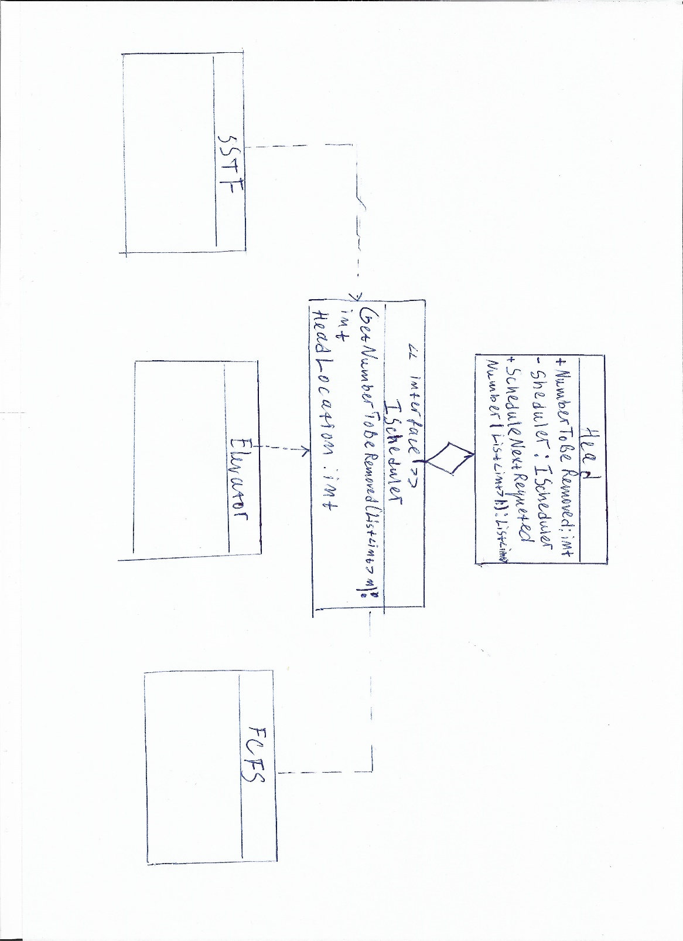

1. Head class – It consists of an instance of the IScheduler interface.

ScheduleNextRequstedNumber () – is a method that makes use of the IScheduler instance and calls the proper method which returns a number that needs to be removed from the current list. After that the method returns the newly updated array.

1. IScheduler interface – it has property HeadLocation which stores the current reading head location.

The method GetNumberToBeRemoved () – Returns the next number to be removed. It is implemented differently based on the type of scheduling method we are using.

1. SSTF, Elevator, FCFS – The different types of disk scheduling, for more algorithm details refer to the code.